BILOMA AFTER PARTIAL CHOLECYSTECTOMY-A RARE BUT EXPECTED COMPLICATION
Makashchieva M. , Petrovska T. , Radeva K. ,Endzekceva A., Taskova A.
University Clinic for Surgical Disease “St.Naum Ohridski” Skopje, Macedonia
Abstract
Biloma is defined as an intrahepatic or extrahepatic bile collection outside the biliary tree with a well-demarcated capsule. Iatrogenic biliary injury, particularly during cholecystectomy, is the predominant causative factor, followed by blunt abdominal injury [1]. Patients may present with abdominal pain, fever, jaundice, leukocytosis, or delayed postoperative recovery, though symptoms can be subtle or nonspecific [2].
We report a case of a patient who developed an intrahepatic biloma with secondary abscess formation after subtotal cholecystectomy for chronic calculous cholecystitis. Initial imaging with ultrasound suggested a subhepatic biloma, which was confirmed and further characterized by contrast-enhanced CT demonstrating multiple collections, the largest measuring 15 × 10 cm with features of early abscess formation. CT-guided percutaneous drainage was performed, with purulent material evacuated. Follow-up CT demonstrated regression of collections, and MRCP confirmed a patent biliary tree without evidence of active bile leak. No ERCP or surgical re-intervention was required. This case highlights the essential role of multimodal imaging in postoperative biliary complications, enabling minimally invasive management and avoidance of unnecessary endoscopic procedures.
Keywords
Biloma, Bile leak, MRCP, Percutaneous drainage, Subtotal cholecystectomy,
Background
Biloma represents a localized collection of bile outside the biliary system, most commonly occurring as a postoperative complication following cholecystectomy or hepatobiliary surgery. Biliary leaks following laparoscopic cholecystectomy can be attributed to damage of the common bile duct (CBD), unsuccessful cystic duct ligation, or anatomical variation leading to damaged or leaking accessory ducts [3]. Infected bilomas can evolve into hepatic abscesses, leading to systemic infection if untreated. Subtotal cholecystectomy is a type of surgical bail-out procedure indicated when facing difficult laparoscopic cholecystectomy due to not reaching the critical view of safety, inadequate identification of the anatomical structures involved and/or risk of injury [4]. Considering the higher risks of complications and mortality, PC should be avoided as long as possible, and patients should always be informed of its clinical outcomes postoperatively [5].
Ultrasonography is generally the first imaging method that detects the presence of a biloma. However, CT demonstrates higher accuracy in determining the possible causes as well as the relationship between the collection and the adjacent structures [6]. MRCP without contrast material is highly sensitive and specific for identifying leaks and allows accurate identification of the biliary anatomy and the location of the leak. [7]
Case Presentation
A female patient with chronic calculous cholecystitis underwent subtotal cholecystectomy due to dense adhesions and difficult anatomy. The immediate postoperative period was uneventful, and the patient was discharged home. Within 3 days, she developed persistent right upper quadrant abdominal pain and mild nausea. She underwent abdominal ultrasound at a local hospital, which demonstrated a subhepatic fluid collection with heterogeneous echogenicity, suggestive of a biloma. She was referred to our tertiary centre for further assessment. Laboratory evaluation revealed mildly elevated inflammatory markers, including leukocytosis and elevated C-reactive protein.
Investigations
Initial CT (postoperative): Contrast-enhanced CT demonstrated a large subhepatic fluid collection measuring 15 × 10 cm, with heterogeneous content and a air-fluid level. The collection showed areas of wall thickening, suggestive of early abscess formation. Adjacent to the inferior margin of the liver, a smaller organized collection measuring approximately 25 × 40 mm was observed. Additionally, a loculated collection measuring 18 × 11 mm was identified in the right paracolic gutter. These findings were consistent with multiple postoperative collections, raising suspicion for biloma with secondary abscess formation. Fat stranding and mild adjacent tissue edema were also noted.
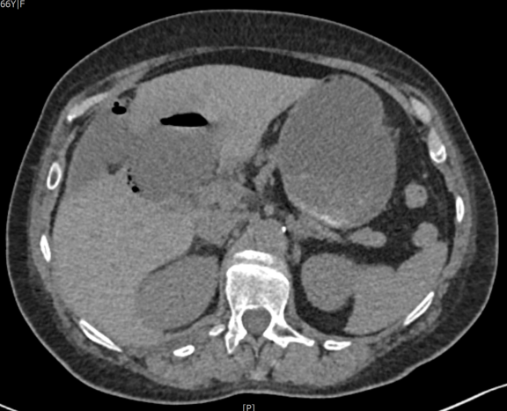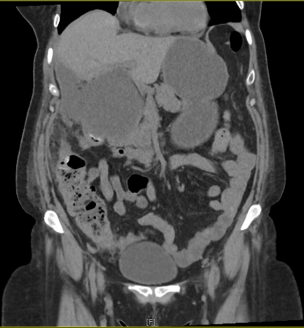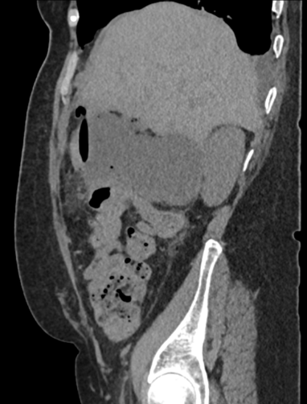
Figure 1. Contrast-enhanced CT images demontratin a large subhepatic fluid collection with air-fluid level, consistent with biloma and early abcess formation. Additional smaller collections are noted adjecent to the liver and in the right paracolic gutter.

CT-guided percutaneous drainage: The largest collection was drained under CT guidance. After local preparation and anesthesia, a 12 Fr drainage catheter was inserted directly into the absceding biloma. Purulent material was immediately evacuated, confirming infected bile. The catheter was initially placed deeply within the collection. During follow-up, the catheter was partially withdrawn to optimize its position and facilitate drainage of residual fluid. The procedure was well tolerated, and the patient remained hemodynamically stable throughout.
Follow-up CT: Follow-up CT demonstrated regression of the previously drained absceding biloma. Residual thin fluid was present at the same anatomical level, but overall size of the collection was significantly reduced. Small basal bilateral atelectasis was noted, and previously observed pleural effusion had resolved completely. No new collections were identified.
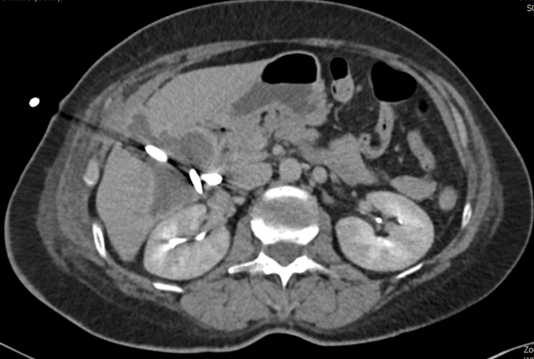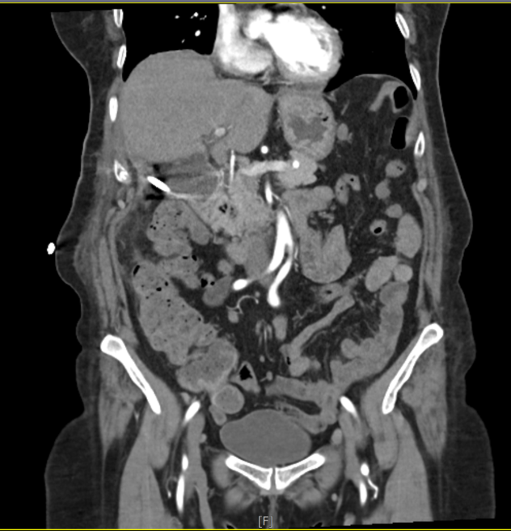
Figure 2. Follow-up contrast-enchanced CT demonstrating significant regression of the previously drained biloma, with the drainage catheter in situ. Only minimal residual fluid is present.

MRCP: MRCP revealed patent intrahepatic and extrahepatic bile ducts without obstruction or choledocholithiasis. The cystic duct stump and a small gallbladder remnant were visualized. No active bile leak was seen, supporting continued conservative management without need for ERCP.
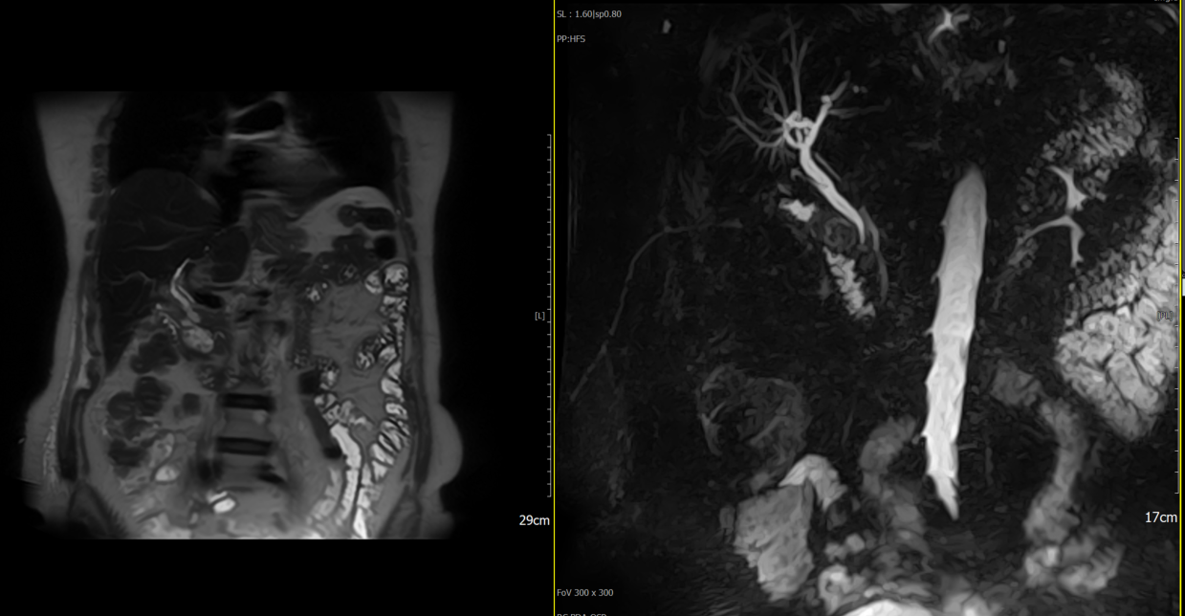
Figure 3. MRCP demontrating patent bile ducts with normal caliber and no evidence of obstruction or filling defects. The common bile duct measured 7 mm. A cystic stump with a small gallbladder remnant is visualised.

Differential Diagnosis [8]
- Perihepatic collection/seroma/lymphocele
- Hepatic cyst
- Hepatic abscess
- Intrahepatic hematoma

Treatment
Management depends on biloma size, leak severity, and the patient’s overall condition. Small, asymptomatic collections may resolve spontaneously, but larger or infected bilomas typically require percutaneous drainage or endoscopic intervention [9]. In our case percutaneous drainage of the largest absceding biloma was performed, with catheter adjustment to optimize drainage. Intravenous antibiotics were administered targeting suspected biliary pathogens. Conservative management was continued, and the patient’s condition gradually improved. No ERCP or surgical intervention was required.
Outcome and Follow-up
The patient demonstrated progressive clinical recovery. Follow-up CT showed significant regression of collections, with residual thin fluid only. MRCP confirmed biliary patency and absence of active bile leak. The patient remained asymptomatic at outpatient follow-up, with normalization of inflammatory markers.
Discussion
Subtotal cholecystectomy is a recognized strategy in difficult gallbladder surgery to reduce risk of bile duct injury. However, postoperative bile leak and biloma formation are common complications. Bilomas may arise from leakage at the cystic duct stump, remnant gallbladder, or intrahepatic ducts, and infected bilomas can evolve into hepatic abscesses. Prompt diagnosis and management are crucial to prevent systemic infection. CT is essential for detecting postoperative collections, measuring their size, characterizing their content, and guiding percutaneous drainage. Drainage catheter placement allows evacuation of infected fluid, reduction of collection size, and resolution of symptoms. Proper positioning of the catheter is important; in this case, partial withdrawal was required to optimize drainage and ensure evacuation of residual fluid. MRCP provides a non-invasive assessment of biliary anatomy and allows evaluation for persistent bile leaks or obstruction. While ERCP is the gold standard for diagnosis and treatment of bile leaks, MRCP can safely identify patients who may not require invasive endoscopy, particularly in stable patients with resolved collections or decreasing drainage output. This case illustrates the complementary roles of CT and MRCP in postoperative biliary complications. CT identifies and guides drainage of collections, while MRCP provides detailed biliary anatomy evaluation. This approach avoids unnecessary ERCP and enables minimally invasive management. The case also emphasizes the importance of follow-up imaging to confirm regression of collections and resolution of abscesses.
Learning Points

• Biloma and secondary abscess formation are significant postoperative complications of subtotal cholecystectomy.
• CT-guided percutaneous drainage is first-line for large or infected bilomas.
• MRCP allows non-invasive evaluation of the biliary tree, guiding the need for ERCP.
• Conservative management with drainage and antibiotics can result in complete resolution without surgical or endoscopic intervention.

Refferences
- https://www.sciencedirect.com/science/article/abs/pii/S0011384017301478
- Balfour J, Desai H, Ewing A. Hepatic Biloma. [Updated 2025 Nov 23]. In: StatPearls [Internet]. Treasure Island (FL): StatPearls Publishing; 2026 Jan-. Available from: https://www.ncbi.nlm.nih.gov/books/NBK574559/
- https://pubs.rsna.org/doi/full/10.1148/rg.210106
- https://pmc.ncbi.nlm.nih.gov/articles/PMC10162495/
- Lee W. Experience with partial cholecystectomy in severe cholecystitis. Korean J Hepatobiliary Pancreat Surg. 2013 Nov;17(4):171-5. doi: 10.14701/kjhbps.2013.17.4.171. Epub 2013 Nov 20. PMID: 26155235; PMCID: PMC4304518.
- Spontaneous biloma: a case report and literature review Gössling PAM, Alves GRT, Silva RVA, Corrêa JRM, Marques HF, Haygert CJP. Spontaneous biloma: a case report and literature review. Radiol Bras 2012;45:59-60
- Patel N, Jensen KK, Shaaban AM, Korngold E, Foster BR. Muktimodality imaging of cholecystectomy complications. Radiographics. 2022;42(5):1303-1319 https://doi.org/10.1148/rg.210106
- https://radiologykey.com/biloma-3/
- Habte Y M, Habte B M, Habte M M, et al. (October 13, 2025) Delayed Biloma Secondary to an Iatrogenic Common Hepatic Duct Injury After Open Cholecystectomy: A Rare Cause of Persistent Biliary Drainage. Cureus 17(10): e94486. doi:10.7759/cureus.94486

