INCIDENTAL RENAL CYSTS ON CHEST CT: A RETROSPECTIVE ANALYSIS OF PREVALENCE AND IMAGING CHARACTERISTICS

Dimitrijevikj K.

¹University clinic of pulmonology and allergology, Faculty of Medicine, Ss. Cyril and Methodius University in Skopje, North Macedonia

Abstract

Introduction: Chest computed tomography (CT) frequently captures portions of the upper abdomen, allowing incidental visualization of renal structures. Renal cysts are among the most common incidental abdominal findings.
Purpose: To determine the prevalence, imaging characteristics, and clinical significance of incidental renal cysts detected during routine chest CT examinations.
Material and Methods: This retrospective study reviewed 1,448 consecutive adult chest CT examinations performed over a seven month period from May-November 2025. Radiology reports were screened for renal findings, and images were re-evaluated when necessary. Renal cysts were categorized using the Bosniak classification. Demographic data and cyst characteristics were recorded. Descriptive and comparative statistics were performed, and interobserver agreement was evaluated using Cohen’s kappa.
Results: Incidental renal cysts were identified in 370 patients (25.6%). Prevalence was higher in men than in women (30.6% vs 19.4%, p < 0.001). The highest number of cases occurred in the 45–65-year age group (54.6%). Cysts were unilateral in 63.8% and bilateral in 36.2% of patients. Cortical cysts predominated (52.2%), while 11.6% were cortico-medullary. Mild hydronephrosis was found in 9.5% of patients. Most patients (55.4%) had a single cyst. Interobserver agreement was substantial (κ = 0.66). Only 2,5 % patients had cysts requiring follow-up (Bosniak II-III).
Conclusion: Incidental renal cysts are common on chest CT and increase with age. Most are simple, unilateral, and benign. Routine reporting of incidental renal cysts is recommended to ensure appropriate follow-up when clinically warranted.
Keywords: Bosniak classification; chest CT; incidental findings; renal cysts; prevalence.

Introduction
Chest computed tomography (CT) frequently captures portions of the upper abdomen, allowing incidental visualization of renal structures. Renal cysts are among the most common incidental abdominal findings and generally represent benign simple cysts (1,2). However, complex cystic lesions with septations, calcifications, or enhancement carry a higher likelihood of malignancy and may require imaging follow-up guided by the Bosniak classification (3,4).
Despite the widespread use of chest CT, the prevalence and clinical relevance of renal cysts detected incidentally on these examinations remain incompletely described. Quantifying the proportion of cysts that warrant further evaluation is important for radiologists and referring clinicians, as incidental findings influence diagnostic workflows, patient management, and imaging resource utilization (5,6). This study aims to determine the prevalence, imaging characteristics, and clinical significance of incidental renal cysts identified on routine chest CT examinations, with emphasis on Bosniak classification distribution and follow-up considerations.

Material and Methods

Study Design and Population
This retrospective study included 1,448 consecutive adult patients (≥18 years) who underwent chest CT at University clinic of pulmonology and allergology- Skopje over a seven-month period from May-November 2025. Of these, 370 patients were identified as having renal cysts and were included for detailed analysis. Both contrast-enhanced and non-contrast scans were eligible. Exclusion criteria included known renal disease, prior renal surgery, or incomplete imaging.

Imaging Technique
Chest CT examinations were performed using multidetector CT scanner PHILIPS INCISIVE 128 slice for optimized thoracic imaging protocols. Although the abdomen was not the primary target, the upper poles of both kidneys were visualized in all cases.

Data Collection
Radiology reports were electronically screened for renal findings. When necessary, images were re-evaluated by two radiologists with three and eight years of experience. Extracted data included number of cysts (single vs multiple), laterality (unilateral vs bilateral), cyst location (cortical, cortico-medullary and medullary), Bosniak classification (I–IV) when applicable, presence of associated findings such as hydronephrosis, and patient age and sex. Patients were stratified into three age groups: 18–40 years, 45–65 years, and >65 years.

Interobserver Agreement
Cohen’s kappa (κ) was calculated to assess interobserver agreement. The junior radiologist identified cysts in 352 patients; the senior radiologist identified cysts in 361 patients. Agreement on cyst presence or absence was recorded for all cases. Interobserver reliability for Bosniak categorization and cyst detection has been previously shown to vary by reader experience and imaging modality (7).

Statistical Analysis
Descriptive statistics summarized demographic and cyst characteristics. Chi-square and t-tests were used for subgroup comparisons. All tests were two-tailed, and a p-value < 0.05 was considered statistically significant. Statistical analyses were performed using SPSS software.

Results:

Study Population
Among 1,448 chest CT examinations, incidental renal cysts were identified in 370 patients (25.6%), including 245 men (30.6%) and 125 women (19.4%). The sex-related difference in prevalence was statistically significant (χ² = 23.74, p < 0.001).

Prevalence by Age Group
Cyst prevalence increased with age:
- 18–40 years: 35 cases (9.5%)
- 45–65 years: 202 cases (54.6%)
- 65 years: 133 cases (35.9%)
More than half of all cysts occurred in patients aged 45–65 years.
Fig-1.
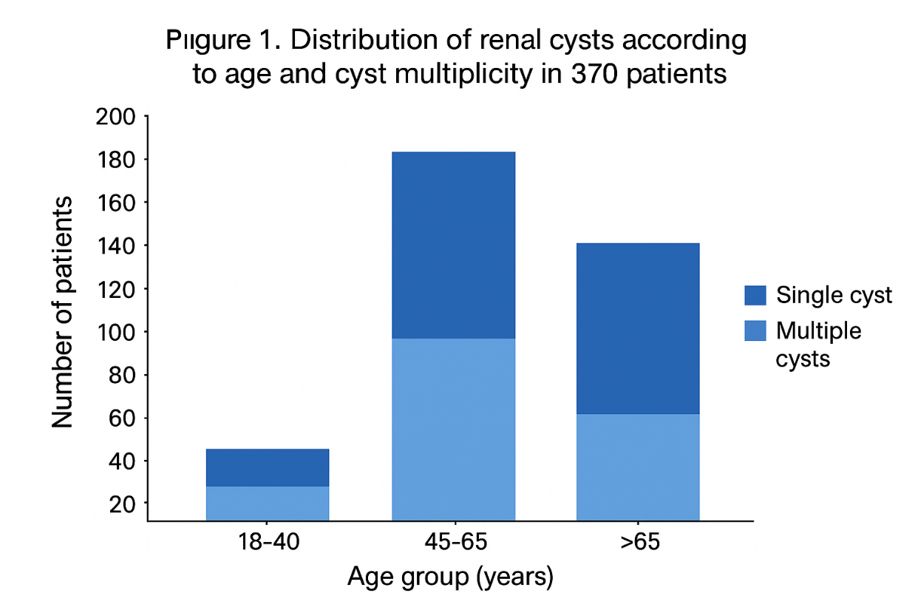

Table 1. Renal Cyst Distribution by Age Group and Multiplicity
Age Group (years) | Total Patients | Patients with Renal Cysts, n (%) | Single Cyst, n (%) | Multiple Cysts, n (%)
18–40 | 37 | 35 (9.5%) | — | —
45–65 | 202 | 202 (54.6%) | — | —
>65 | 133 | 133 (35.9%) | — | —
Total | 370 | 370 (100%) | 205 (55.4%) | 165 (44.6%)

Fig-2.
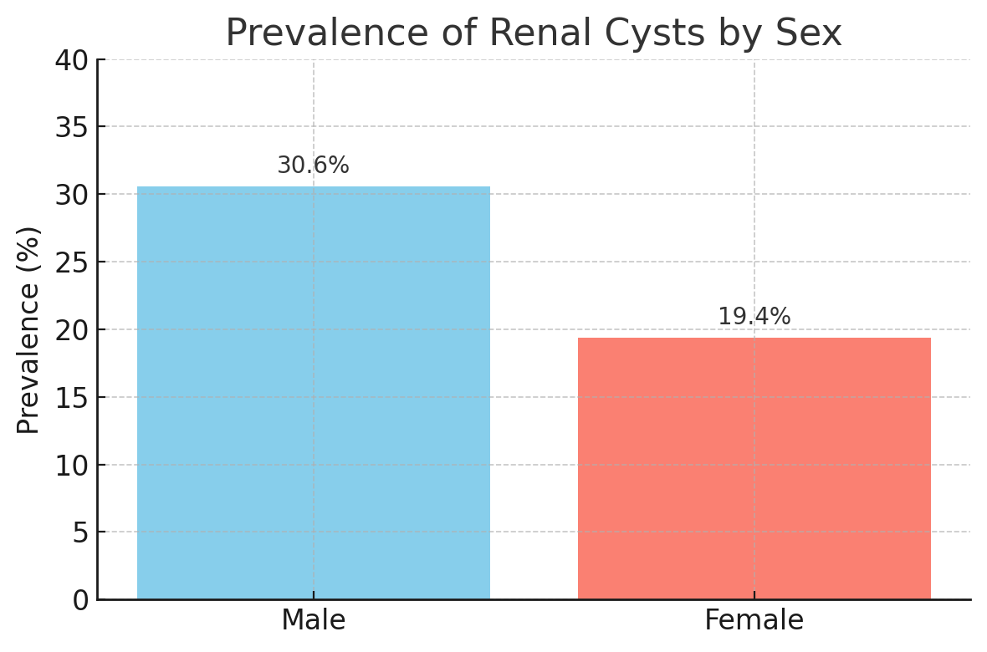

Cyst Characteristics
- Laterality: Unilateral in 236 patients (63.8%); bilateral in 134 patients (36.2%).
- Location: Cortical in 193 patients (52.2%); Cortico-Medullary in 134 pstients (36,2%), Medullary in 43 patients (11.6%).
- Multiplicity: Single cyst in 205 patients (55.4%); multiple cysts in 165 patients (44.6%).
- Associated findings: Mild hydronephrosis in 35 patients (9.5%). No severe hydronephrosis were observed.

Fig-3.
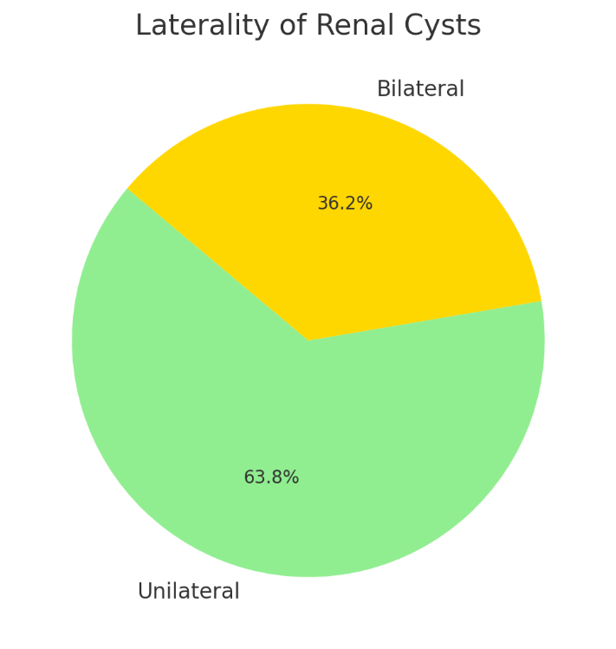
Fig-4.
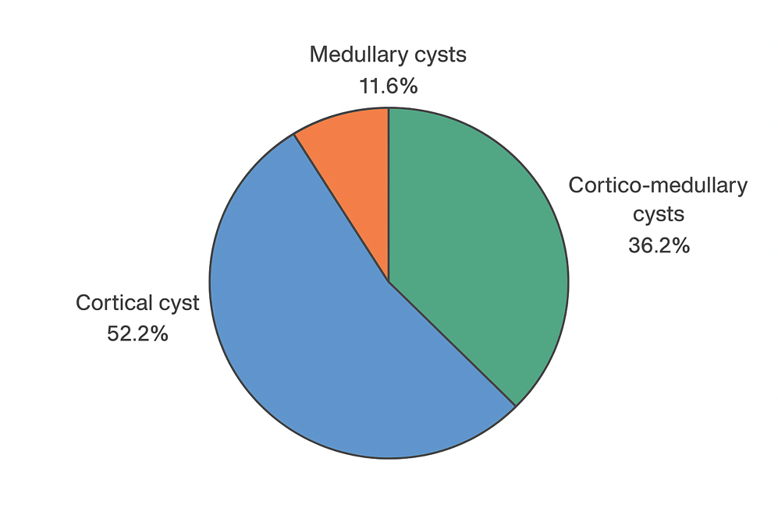

Bosniak Classification
The majority of cysts were benign simple cysts:
Table 2. Bosniak Classification of Renal Cysts
Bosniak Type | Number of Patients (n) | Percentage (%)
I | 361 | 97.6
II | 8 | 2.2
III | 1 | 0.3
IV | 0 | 0

Only 9 patients (2.5%) had cysts requiring follow-up (Bosniak II–III), whereas the vast majority (97.6%) were simple, benign cysts not requiring additional imaging.
Fig-5.
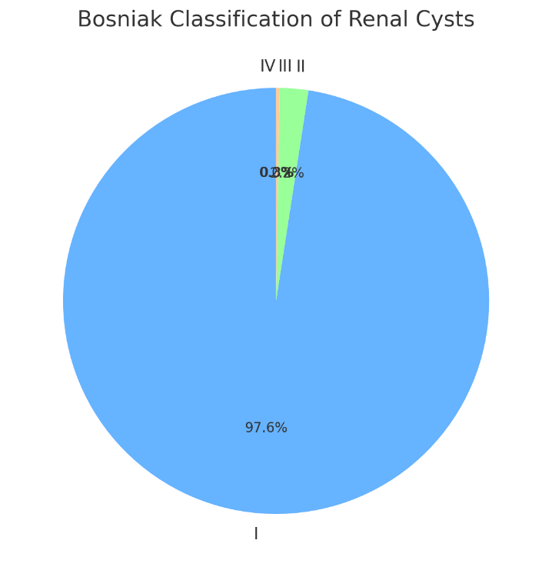

Interobserver Agreement
Overall observed agreement was 97.6%. Cohen’s kappa was κ = 0.66 (95% CI: 0.52–0.80), indicating substantial interobserver agreement.

Discussion
In this large retrospective cohort, incidental renal cysts were identified in 25.6% of chest CT examinations, consistent with previously reported prevalence rates of approximately 20–30% in adult populations (1,2,8). The significantly higher prevalence among men is in keeping with prior epidemiological reports and may reflect sex-specific biological or environmental factors (5,11).
Cyst occurrence increased progressively with age: the majority of cases were observed in patients aged 45–65 years, with continued high prevalence in those >65 years. This pattern corroborates prior population-based studies linking aging to an increased burden of simple renal cysts, likely due to degenerative tubular changes (8,9,10). The low prevalence in younger adults supports the predominantly degenerative etiology of simple renal cysts (1).
Most cysts in our cohort were unilateral and cortically located, characteristics typical of benign simple cysts (3,4). Mild hydronephrosis was uncommon and only 2,5 % of cysts required follow-up; this finding underscores the predominantly benign nature of incidental renal cysts when limited upper pole coverage is obtained on chest CT (5,6). Nonetheless, accurate Bosniak categorization and reporting are essential to identify the small subset of complex cysts that warrant further evaluation or referral (3,4).
Interobserver agreement in our study was substantial (κ = 0.66), consistent with prior reports that demonstrate moderate-to-substantial reliability for cyst detection and Bosniak classification, particularly when reader experience and dedicated abdominal imaging are available (7,11). The high observed agreement (97.6%) reflects reproducible detection of visually appreciable cysts on chest CT despite variable abdominal coverage.
These results support routine inspection and standardized reporting of renal findings on chest CT to ensure clinically relevant incidental lesions are recognized and managed according to best practice recommendations (12,13).

Conclusion
Incidental renal cysts are common on chest CT, affecting approximately one-quarter of patients. Prevalence increases markedly with age and is higher in men. Most cysts are unilateral, cortical, and benign; very few are associated with hydronephrosis and only 2,5 % of the cysts in this cohort needed follow up. Routine documentation of renal cysts during chest CT interpretation is recommended to support consistent reporting and appropriate follow-up when indicated.
Ethics approval protocol number – not applicable.
Author contributions statement – The author confirms sole responsibility for the conception, design, analysis, interpretation and writing of this manuscript.
Conflicts of interest declaration- I declare Non Conflict of interes.t
Funding information-The author declares that no funding was received for this study

References:

- StatPearls Contributors. Simple renal cyst. StatPearls, Treasure Island (FL): StatPearls Publishing; 2023.
- Chang CC, Chiang HS, Tsai JC, et al. Prevalence and clinical characteristics of simple renal cysts. J Chin Med Assoc. 2007;70(11):486–491.
- Silverman SG, Israel GM, Herts BR, Richie JP. Bosniak classification of cystic renal masses, version 2019: an update proposal and review of the literature. Radiology. 2019;292(2):475–488.
- Schoots IG, van den Hoogenband HM, Zietse R, et al. Bosniak classification for complex renal cysts reevaluated: a systematic review and meta-analysis. J Urol. 2017;198(4):777–786
- Corwin MT, Keener JD, Chowdhry M, et al. Prevalence of solid tumors in incidentally detected renal masses on CT. AJR Am J Roentgenol. 2018;211(5):1072–1078
- Terada N, Hamano T, Hanaki K, et al. Natural history of simple renal cysts: a longitudinal ultrasound study over six years. J Urol. 2001;166(6):1939–1941.
- Pfister M, et al. Prevalence of renal cysts and association with risk factors in a general population: an MRI-based study. J Nephrol. 2018;31(6):941–950.
- Pearce I, et al. Comparison of Bosniak classification of cystic renal masses version 2019 assessed by CT and MRI. Clin Radiol. 2021;76(9):712–720
- Wu Q, Zhao J, Li X, et al. Prevalence, risk factors and clinical characteristics of renal cysts: a population-based study. Int Urol Nephrol. 2022;54(3):561–571
- Radiology Assistant. Bosniak classification 2019 — practical summary and recommendations. RadiologyAssistant.nl.
- Patel MR, Kambadakone AR, Kuo J, et al. Management of incidental renal lesions on imaging: A survey of current practice patterns. J Comput Assist Tomogr. 2022;46(5)
- Meyer HJ, Müller M, Schenck P, et al. Renal incidental findings on computed tomography: Frequency and distribution in a large non-selected cohort. Eur Radiol. 2017;27:3044‑3052. doi:10.1007/s00330-017-4785-4
- Johnston MG, Patel V, Smith K, et al. Standardized follow-up recommendations improve reporting of incidental renal lesions in a community setting. Abdom Radiol (NY). 2023;48:1234‑1242. doi:10.1007/s00261-022-03751-8

